**MAIN HEADERS FOR WEBSITE:**

**HOME**

**ABOUT SDG CAMPUS CLUB**

**ABOUT SDGs**

**SDG INTERNATIONAL FILM FESTIVAL**

**WEBINARS AND EXPERT TALKS**

**PARTNERS**

**FAQ & CONTACT**

1. Home

**SECTION 1) ABOUT SDGs**

**Webinars & Expert Talks**

**Get a chance to attend the pre and post festival webinars and expert talks on registering for the film festival.**

**International Networking**

**Be the part of a diverse community of change driven college students and working professionals. Opportunities for collaborative projects and cross cultural exchange during the festival.**

**Documentary Screening**

**Enjoy an exclusive screening of our selected award winning documentaries and short films throughout the 2 days and interact with the Directors live and ask questions.**

**Certificates & Recognition**

**Get a recognition certificate from NIT Rourkela for being a delegate at the International Film Festival including Special Certificates for Heads of Delegations of Colleges and Universities.**

**SECTION 3)**

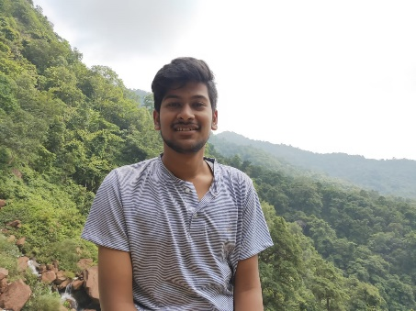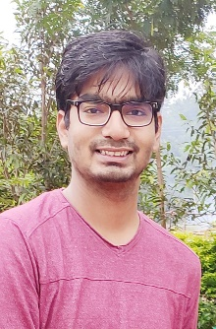**OUR TEAM**

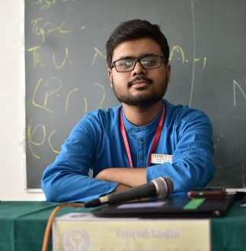

**Pratyush Ranjan Satyajit Raiguru Suman Acharya Jitamitra Sahu**

**President Vice President Secretary Treasurer**

**Pratyush Ranjan**

Facebook : https://www.facebook.com/pratyush.ranjan.33483903

Instagram : https://www.instagram.com/pratyush11.05/?hl=en

**Suman Acharya**

Facebook : https://www.facebook.com/suman.acharya.543

Instagram : https://www.instagram.com/sumhack07/?hl=en

**Jitamitra Sahu**

Facebook : https://www.facebook.com/jitamitra.sahu

Instagram : https://instagram.com/jitamitra.sahu?igshid=lw46sip9f1a6

**For Footer:**

[**https://www.facebook.com/sdgcampusclubnitrkl**](https://www.facebook.com/sdgcampusclubnitrkl) **- Facebook Handle**

[**https://www.instagram.com/sdgcampusclub_nitrkl/**](https://www.instagram.com/sdgcampusclub_nitrkl/) **- Instagram Handle**

1. 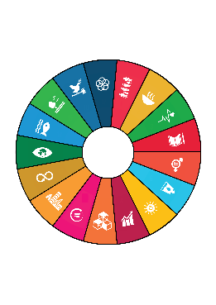About SDG Campus Club, NIT Rourkela

The inception of the SDG Campus Club was based on the theme of promoting the 17 Sustainable Development Goals of the United Nations and conducting events and seminars for raising awareness about them within the students and faculty. The SDGs encompass all aspects of societal development including – Environment Protection, alleviating poverty, promoting healthy lifestyle, Promoting Sustainable use of energy and maintaining proper hygiene, Women Empowerment, Education for all etc. and act as parameters for a developmental index. Being the first of its kind among the all other social service clubs on campus – this club would not just be limited to conducting direct events with NGOs and Governmental Organizations but also conducting conferences, seminars, marathons, awareness weeks, etc. in collaboration with other clubs under the society including of the likes conducted by the literary clubs.

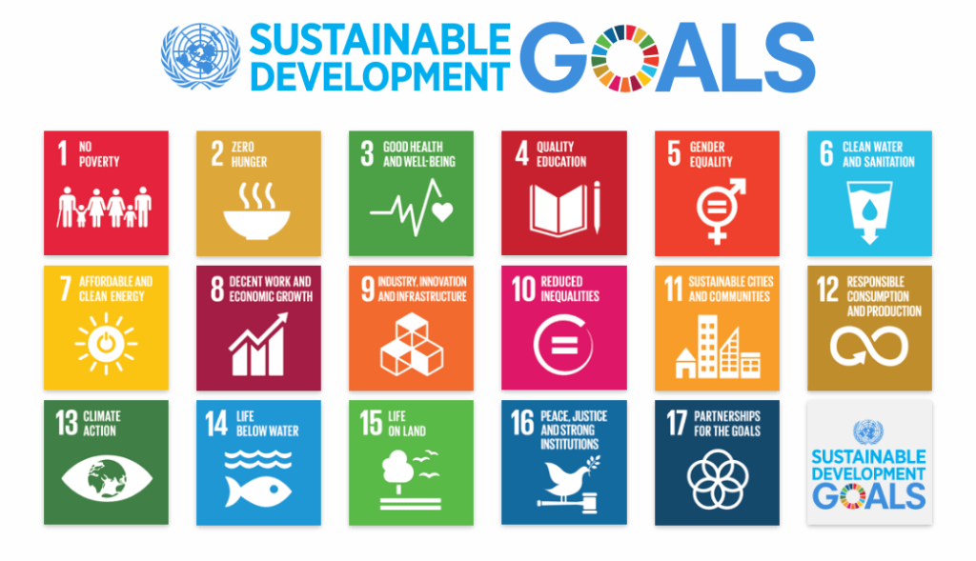

The Club is organizing the SDG International Film Festival of NIT Rourkela on 3rd and 4th of October. Please check the **International Film Festival** section for more details regarding the detailed itinerary including speakers and list of documentaries & short films to be screened in the festival.

1. About SDGs

The United Nations **Sustainable Development Goals** are the blueprint to achieve a better and more sustainable future for all.

Refer the Booklet on SDGs for Remaining Content in this section

1. SDG International Film Festival

The SDG International Film Festival aims to bridge the gap between policy makers, civil society, non-profits and the youth. Through the 2-day festival which would involve **online screening of award-winning documentaries and short films** based on the various SDG thematic areas as well as **pre-conference talk series with various experts,** we hope to make it an enriching experience for both the participants and other stakeholders.

The screening of the short films shall also be followed by a **live interaction with the directors and actors of the documentaries who would provide a short keynote on the inspiration behind making the short film followed by a question and answer session with the audience.**

Short Films and Feature Documentaries

(To be screened at the Film Festival)

1. Create 2030 (<https://www.youtube.com/watch?v=ROzXn5ldwxc&list=PLpr1sw3X4GPDFopSzV9Y9zYIGvJq6CyiF&index=4>)



1. Sayang Kalimantan

(<https://www.youtube.com/watch?v=vVMHO6VpcjU&feature=youtu.be&list=PLEXw1ZgSf5_pBhwZL2gPB3Kd2r6QKHbrD>)

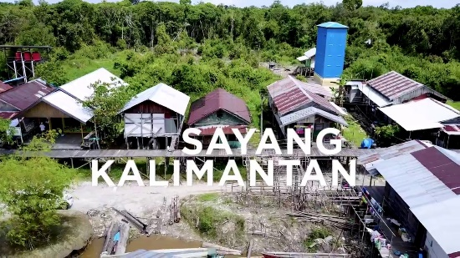

1. Protecting Our Planet: Aquastory

(https://www.youtube.com/watch?v=fXjK7rd6cG0&ab_channel=LisboaE-Nova)

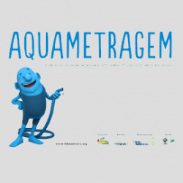

1. Sustainable Futures: Survivor Girls
2. Mr. Toilet: The World’s #2 Man
3. The Conductor

(<https://www.youtube.com/watch?v=pBx6JHvTjxM>)

1. Architecture, Life, Dialogue

(<https://www.youtube.com/watch?v=IUFadtDuRLM>)



Speakers & Guests

1. Lisa Russells



1. Wally Tham



1. Diana Henriques



1. Nicole Watson



1. Jack Sims



1. Inessa Kraft



1. Bethany Borg



1. Webinars & Expert Talks



* **Ashley Maria**

**Topic:** Gender Equality : A Global Perspective

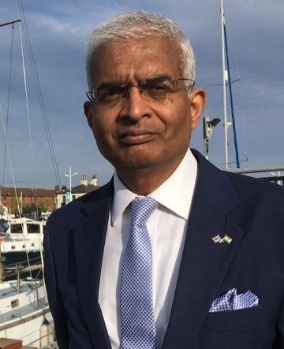

* **Sunil Murlidhar Shastri**

**Topic:** Ocean Governance and Blue Economy

**6)** Partners

**Sponsors**

Farm to Fork Solutions



**Organizational Partners**

Phoenix Events & Entertainment

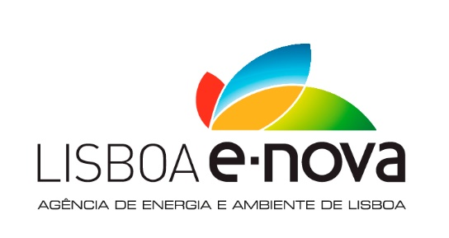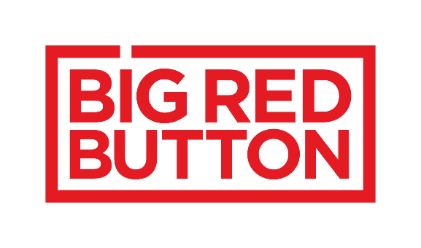

**Clubs & Student Bodies**

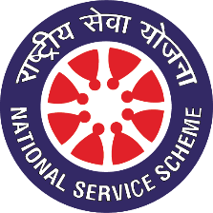

NSS NIT Rourkela

**7) FAQ & Contact**

FAQ (Take Inspiration from <https://nitrimun.org/FAQ.html>)

* What is the SDG International Virtual Film Festival all about and who is organizing it?

Ans. The SDG International Film Festival aims to bridge the gap between policy makers, civil society, non-profits and the youth. Through the 2-day festival which would involve **online screening of award-winning documentaries and short films** based on the various SDG thematic areas as well as **pre-conference talk series with various experts,** we hope to make it an enriching experience for both the participants and other stakeholders.

* Who can participate and what are the dates of the Film Festival?

Ans. Any School or College student is free to participate as a Delegate at the SDG International Film Festival. Working Professionals can also participate in the Festival by mentioning the name of their organization on the registration form.

* Is there a registration fee for attending the Film Festival? Also do I need to be a part of a college delegation to participate in the Film Festival?

Ans. No, the Film Festival is completely free to attend for anyone who is committed towards promotion of the United Nations Sustainable Development Goals. There are two modes of participation either as a part of an institutional delegation which needs to be communicated earlier to us through mail or by individual registration on the Google Form.

* What are the other benefits and perks of attending the Film Festival?

Ans. The Film Festival has 2 segments:

1. Pre & Post Festival Webinars and Expert Talks on individual SDG areas by Prominent Personalities.
2. The SDG Film Festival itself on 3rd and 4th October which would involve screening of award winning selected short documentaries and films on various SDG thematic areas. This shall also be followed by an address by each Documentary Director Live and Question and Answer session with the Delegates.

All registered delegates will receive prior communication to attend the Pre and Post Festival webinars apart from the Film Festival. Special Certificates shall be provided to Heads of Institutional Delegations and Participation Certificate to all registered Delegates of the Film Festival. A Post Festival speed networking session on zoom with all delegates is also expected to be organized by the Club.

* How to register for the Film Festival and take part?

Ans. You can register by filling the form at <https://bit.ly/2R4xr5l> or by clicking the Register Button on the website.

|  |
| --- |
| Reach out to us at:  MAKE A FORM (NAME, EMAIL ID, PHONE NUMBER, MESSAGE) |